**CL22.399 Development Application – RA21/1001 – 17 Norfolk Avenue, South Nowra – Lot 116 DP 1122371**

**DA. No:** RA21/1001/4

**HPERM Ref:** D22/331453

**Department:** Development Services

**Approver:** James Ruprai, Director - City Development

**Attachments:** 1. Assessment Report (under separate cover)

2. Draft Conditions of Consent (under separate cover)

3. SDCP 2014 Assessment (under separate cover)

**Description of Development:** 47 industrial units, ancillary café, access, signage, and ancillary works

**Owner:** Shoalhaven City Council

**Applicant:** Richard Amos c/- SET Consultants

**Notification Dates:** 8 December 2021 to 7 January 2022

**No. of Submissions:** One (1)

Purpose / Reason for consideration by Council

To present the Development Application to Council to enable review the section 4.15 assessment report and draft determination (prepared by an independent consultant) in advance of a meeting of the Southern Regional Planning Panel so that Council’s view on the proposal can be put to the Panel.

|  |
| --- |
| Recommendation  That:   1. Council receive and note the s4.15 assessment report for RA21/1001 – 17 Norfolk Ave South Nowra. 2. Council support RA21/1001 for industrial units at 17 Norfolk Ave South Nowra, on the basis that the application has been satisfactorily assessed pursuant to section 4.15 of the *Environmental Planning and Assessment Act 1979* and will provide additional industrial premises for local businesses. 3. The resolution made by Council be submitted to the Southern Regional Planning Panel prior to their consideration and determination of RA21/1001. |

Options

1. Support the consultant’s recommendation to the Southern Regional Planning Panel (SRPP) for approval of the application by deferred commencement consent and advise the SRPP accordingly.

Implications: The recommendation would be provided to the SRPP for their information as part of their consideration of the regional application.

1. Make an alternative resolution and make a separate submission to the SRPP.

Implications: The alternative resolution would be provided to the SRPP for their consideration.

The SRPP is the determining authority for the application.

Location Map

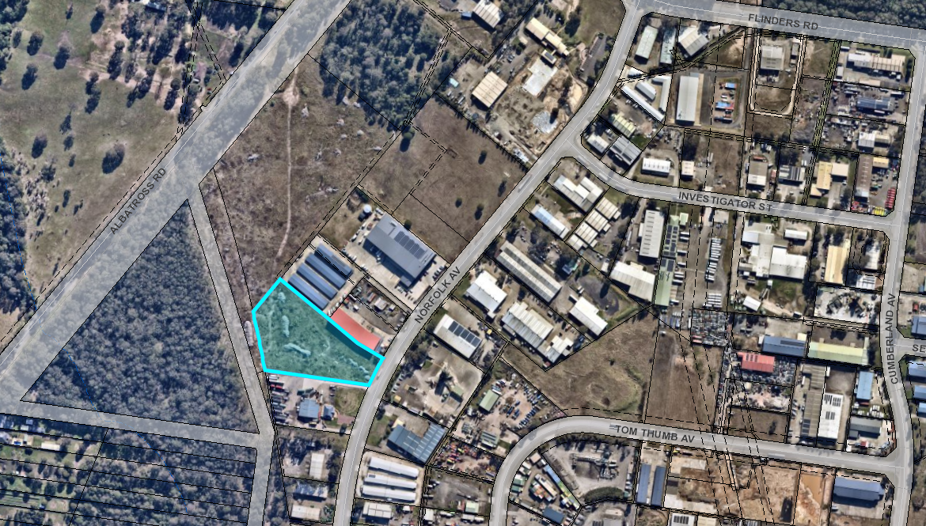

*Figure 1 – Site location / Aerial view*

Background

*Why this DA is being reported to the Regional Planning Panel*

* The development has a capital investment value (CIV) of more than $5 million. The CIV is $8,334,817.
* Shoalhaven City Council has an interest in the proposal being owner of the land.
* The Southern Regional Planning Panel is the determining authority for the application in accordance with section 3 of Schedule 6 of *State Environmental Planning Policy (Planning Systems) 2021,* (SEPP).

The determination by a Panel also adds a layer of transparency to the assessment process. Furthermore, the application was also independently assessed by a reputable Planning Consultancy – [Creative Planning Solutions.](https://www.cpsplanning.com.au/town-planning) These measures are intended to deal with any potential conflicts of interest.

*Proposed Development*

Council is in receipt of a development application (DA) which seeks approval for 47 industrial units. Minor cut and fill for site preparation is proposed. The proposal will also provide an ancillary ‘café’, a total of 116 parking spaces (two (2) of which will be accessible spaces), and associated works. The units will include mezzanine and ‘optional mezzanine’ levels to each of the proposed units. The uses of the individual units have not been nominated. Hours of operation have been nominated as 7.00am to 5.00pm Monday to Saturday.

The proposed site plan and elevations are provided in **Figures 2-6.**

*Figure 2 – Cover sheet – site plan and overview*

*Figure 3 – Boundary Elevations*

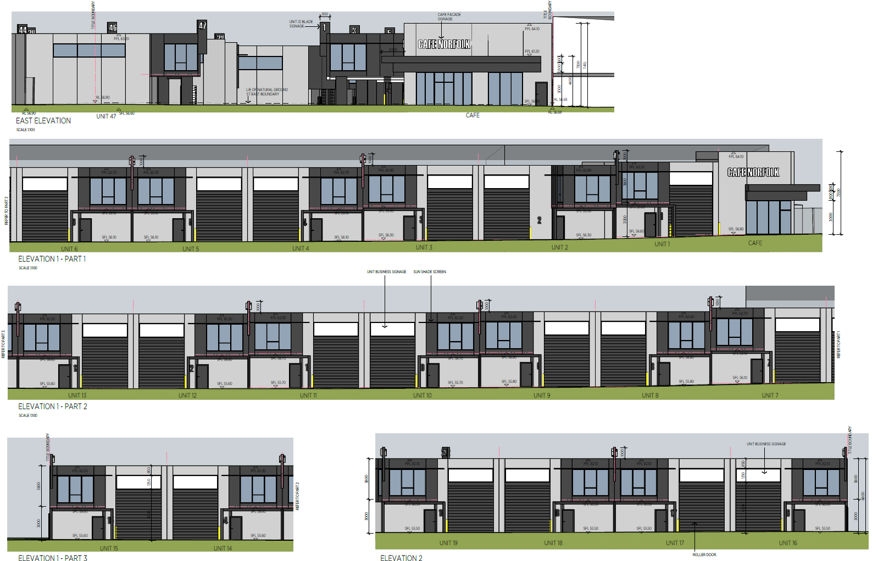

*Figure 4 – Internal Elevations a*

*Figure 5 – Internal Elevations b*

*Figure 6 – Internal Elevations c with signage detail*

*Subject Land*

The subject land is Lot 116 DP 1122371 (known as 17 Norfolk Avenue, South Nowra). The land has an area of 1.350ha and is cleared of vegetation. There are existing industrial developments within the locality. The land fronts Norfolk Avenue and is mapped as bushfire prone land. The land is zoned IN1 General Industrial under the *Shoalhaven Local Environmental Plan 2014* (SLEP 2014), under which a variety of uses are permitted with the consent of the determining authority.

The objectives of the IN1 General Industrial zone include:

* *To provide a wide range of industrial and warehouse land uses.*
* *To encourage employment opportunities.*
* *To minimise any adverse effect of industry on other land uses.*
* *To support and protect industrial land for industrial uses.*
* *To allow a diversity of activities that do not significantly conflict with the operation of existing or proposed development.*
* *To enable other land uses that provide facilities or services to meet the day to day needs of workers in the area.*

The proposal is not inconsistent with the objectives of the zone.

*Site & Context*

The subject land is situated within the Flinders Industrial Estate. There is a range of existing industrial uses in this location.

*Planning Assessment*

Due to the subject land being in Council ownership, with sale pending, the DA has been assessed by an independent consultant.The assessment report has been completed, and the Regional Planning Panel is to determine this DA.

The DA has been assessed under s4.15 of the *Environmental Planning and Assessment Act 1979*. Please refer to **Attachment 1.**

Issues

The Café

The independent assessment has recommended changes to the café so that it operates as a food and drink premises which is permissible in the zone, noting that a café is prohibited. To clarify, a take away food and drink premises is defined as follows:

***Take away******food and drink premises*** *means premises that are predominantly used for the preparation and retail sale of food or drink (or both) for immediate consumption away from the premises.*

***Note—***

*Take away food and drink premises are a type of food and drink premises—see the definition of that term in this Dictionary.*

A café is a type of food and drink premises which is defined as:

***Food and drink premises*** *means premises that are used for the preparation and retail sale of food or drink (or both) for immediate consumption on or off the premises, and includes any of the following—*

1. *a restaurant or cafe,*
2. *take away food and drink premises,*
3. *a pub,*
4. *a small bar.*

***Note—***

*Food and drink premises are a type of* ***retail premises****—see the definition of that term in this Dictionary.*

As per the note above, a ‘food and drink premises’ is a type of ‘retail premises’. ‘Retail premises’ are prohibited within the IN1 zone under the SLEP 2014.

To deal with this issue, it is recommended that the layout be adjusted and the reference to café be removed from the plans

Shoalhaven Development Control Plan 2014 (SDCP 2014) Performance / Alternative Solutions

There are areas of ‘non-compliance’ in relation to the proposal. This is explained and addressed in detail through the s4.15 Assessment Report (**Attachments 1 & 3**).

The planning assessment identified issues with Chapters G1, G20, G21 and G22. These relate to:

* the site analysis plan,
* inadequate solar access information,
* a front setback variation,
* the length of unbroken walls along the side elevations of the building,
* inadequate pedestrian facilities,
* inadequate manoeuvring space for large vehicles, and
* the size of free-standing signage at the front of the site.

The planning assessment has found that the departures from the acceptable solutions are either justifiable and/or can be addressed by conditions in the event of approval.

In summary:

Site analysis – Information provided to Council (i.e., a survey plan, site plan, etc.) is sufficient for an assessment to identify hazards and constraints, noting that there are no trees on the site, and the site is not constrained by considerations such as views and natural hazards other than bushfires. The lack of a specific site analysis plan is therefore considered to be acceptable in this instance.

Solar access information – Solar access plans were provided showing overshadowing impacts for 22 September rather than for June. Despite such a deficiency, the layout of development on the adjoining industrial site to the south and the proximity of the subject site to the nearest residential development is such that the proposal will not adversely affect the amenity of areas sensitive to overshadowing.

The front setback – The element that breaches the numerical setback is an open / lightweight element that is to be finished in contrasting colours, below the roof parapet at the front of the building. It is the cantilevered ‘café’ awning.

There is a landscape area in front which will be enhanced as a result of the removal of outdoor dining. The building element that protrudes (awning) does not add to size and bulk.

Proposed setbacks:

* To café roof ‘awning: 12.98m
* To building line: 15m

The acceptable solution is a front setback of 15m. The nominated 12.98m setback to the awning is considered an acceptable performance solution.

Length of walls – The visual impact of the development will be reduced to the north, as a result of existing development at 15 Norfolk Avenue that is already built with a zero-side setback to the common boundary. While the location of development on the adjoining site to the south (i.e., 19 Norfolk Avenue) will allow for the variation to be visible from the Norfolk Avenue road reserve, the development controls for the locality likely envision the setbacks of future development to be more akin to that proposed by the subject DA.

It is agreed with the applicant’s Statement of Environmental Effects (SEE’s) arguments that there are numerous other examples within the Flinders Industrial Estate where industrial developments have been permitted with large unbroken expanses on/close to side boundaries; a review of the area noted examples including:

* 11 Norfolk Avenue
* 35 Norfolk Avenue
* 10 Tom Thumb Avenue
* 28 Trim Street

It is also agreed that the variation will not adversely affect the amenity of surrounding sites (noting that such sites either contain other industrial developments or will remain undeveloped for the foreseeable future), nor will the variation adversely affect defence against bushfires.

Pedestrian facilities – While no issue is raised with the design of facilities for vehicular entry and egress, the proposed development does not demonstrate satisfactory provisions for pedestrian safety. While the site provides for continuous and line-marked paths of travel between the front of the site and Units 1-15 and 36-37, line-marked pathways do not connect these pathways to buildings that will contain Units 18-22 and 23-30.

A condition is therefore recommended that will require amendments to be made to ensure that adequately marked and connected pedestrian pathways are provided through the site in accordance with relevant standards; the condition will require such pathways not be permitted to encroach upon proposed landscaped areas, in order to both maximise landscaped area and visibility of pedestrian routes throughout the site.

Manoeuvring space for large vehicles – The swept path plans provided with the most recent amendments to the plans indicate that the DA seeks consent for access for vehicles up to and including 19-metre-long articulated vehicles (i.e., semi-trailers).

The submitted swept path plans are inadequate, as they indicate that:

* Access from the south is only attainable by using the south-bound lane of Norfolk Avenue (i.e., access from the south requires using the wrong side of the road).
* Egress to the north is only attainable by using the south-bound lane of Norfolk Avenue (i.e., egress to the north requires using the wrong side of the road), and also requires encroachment upon the centre dividing island.
* Manoeuvring space around Unit 23 requires encroachment upon landscape areas (noting that the landscape plans propose wider landscaped areas within this location).
* Manoeuvring space around Unit 24 requires encroachment upon landscape areas.
* It has not been demonstrated that articulated vehicle access and associated manoeuvring to Units 10-15 and 16-19 is possible without reversing a significant distance within the site.
* The proposed loading areas within the industrial units are of insufficient lengths to accommodate a 19-metre-long vehicle without significant encroachment into the ’avenues’ throughout the site, and no shared loading facilities for a 19-metre-long vehicle are proposed.

Swept path plans for Heavy Rigid Vehicles (HRVs) also show an impractical approach angle to the site in addition to encroachment upon landscaped areas in order to manoeuvre around Unit 23.

No justification has been provided with regard to the above.

In addition to recommended conditions of consent by Council’s Development Engineer, the following consent conditions are recommended that will require the following:

* Prohibition of articulated vehicles from the site, with signage to be erected at the entrance to the site to advise incoming traffic of this restriction.
* Revised swept path plans for HRVs are to be submitted for Council’s approval prior to the issue of a Construction Certificate.

Size of sign – the acceptable solutions are:

* A1.4 Maximum sign face area should not exceed 0.35m2 of sign face area per linear metre of road frontage.
* A1.5 Maximum sign face area of any one (1) sign is not to exceed 8m2.

The signage proposed is:

* A1.4 - 2.23m2 (or 15.8%)
* A1.5 - 8.38m2 (or 104.8%)

The variation to the signage area is likely a consequence of the large number of proposed units (and the subsequent need to provide sufficient space on the free-standing sign to provide business identification signs for all proposed businesses), and the design of the free-standing sign will promote suitable rationalisation of signage in areas immediately visible from the public domain. Given the size of the site, site frontage and proposed development, the size of the proposed signage variation is not significant, therefore any variation to the permitted signage area will not be discernible when viewed from the public domain.

Having regard to the particular circumstances of the site, the proposal is unlikely to set an undesirable precedent. The proposed variation is therefore considered to be satisfactory and supportable on merit in this instance.

Deferred commencement condition recommendation

The approval is recommended as a deferred commencement consent requiring an easement for drainage, and as easement for APZ to be created over adjoining Lot 40 DP 802671, which is Council Operational land to support the development, **(Attachment 2).**

Deferred commencement is considered appropriate in this instance to ensure the proposal can appropriately connect to the stormwater drainage system to support the development prior to the consent becoming operative, and provide the necessary defendable space as required by Planning for Bushfire Protection.

Upon registration of the easements, the consent will convert to an operational consent.

Consultation and Community Engagement:

The DA was notified in accordance with the *Environmental Planning and Assessment Regulation 2021* (EP&A Regs) and Council’s Community Consultation Policy for Development Applications from **8 December 2021** to **7 January 2022**.

One (1) public submission was received in relation to Council’s notification of the development.

The key issue raised as a result of the notification was the Intensification of traffic – in relation to impacts on traffic / existing nearby development.

The submission:

“…*requests that Council carefully consider the intensification of the industrial area, particularly in relation to impacts of increased traffic, the interaction of light and heavy vehicles, and vehicle safety entering/exiting driveways in the vicinity of a busy concrete plant*.*”*

It has been found that, subject to the recommended conditions of consent, the proposed development:

* Will provide for adequate parking,
* Will not result unacceptable impacts noting the subdivision is capable of accommodating the envisaged traffic, and
* Will allow for adequate vehicular access and egress in a manner that will not adversely affect surrounding sites.

Financial Implications:

There are potential cost implications for Council in the event of a refusal of the application. Such costs would be associated with defending an appeal in the Land and Environment Court, should the applicant utilise appeal rights afforded under the *Environmental Planning and Assessment Act 1979* (EP&A Act).

Legal Implications

Pursuant to section 8.2 of the EP&A Act, a decision of the Panel may be the subject of a review by the applicant in the event of approval or refusal. If such a review is ultimately pursued, the matter would be put to the Panel for consideration.

Alternatively, an applicant may also appeal to the Court against the determination pursuant to section 8.7 of the EP&A Act.

Summary and Conclusion

The planning assessment has concluded that the current proposal meets the provisions of relevant environmental planning instruments and is consistent with the relevant provisions and objectives within the *Shoalhaven Local Environmental Plan 2014* (SLEP 2014) and the Shoalhaven Development Control Plan 2014 (SDCP 2014). Any potential impacts have been adequately addressed via recommended conditions of consent.

This application has been satisfactorily (and independently) assessed having regard for section 4.15 (Evaluation) under the EP&A Act. Based upon the recommendations of the s4.15 Assessment Report - **Attachment 1**, Development Application No. RA21/1001 is recommended to the Regional Planning Panel to be granted deferred commencement consent subject to the draft conditions of development consent contained in **Attachment 2**.